**Résumé**

**Name :** Aakash Mallick

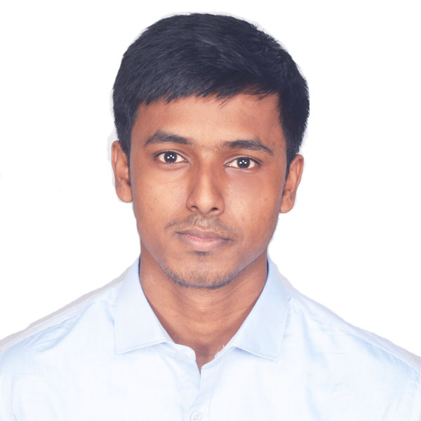

**Contact Number :** +91 7980940412

**Email** **:** [aakashhmallick88@gmail.com](mailto:aakashhmallick88@gmail.com)

**Career Objective**

To work for an organization which provides me the opportunity to improve my skills, knowledge and to cater to the needs of the organization’s objective.

**Personal Qualities**

* An enthusiastic fresher with leadership skills and highly motivated, having bachelors of engineering degree in Computer Science and Engineering from **Future Institute of Engineering and Management.**
* Eager to learn new technologies and methodologies.
* Always willing to innovate the new things which can improve the existing technology.

**Academic Qualification:**

**Secondary & Higher Secondary**

|  |  |  |  |  |  |
| --- | --- | --- | --- | --- | --- |
| **Examination** | Board | **Year of Passing** | **Marks** | | |
| **Obtained** | **Out of (Total)** | **%** |
| **10th Std** | ICSE | 2013 | 563 | 600 | 92.83 |
| **12th Std** | ISC | 2015 | 557 | 600 | 93.83 |

|  |  |
| --- | --- |
| **ICSE** – 94.2% (Best of 5 subjects) | **ISC –** 95.75 (Best of 4 Subjects) |

**Graduation: B-Tech in CSE**

|  |  |  |  |  |  |  |
| --- | --- | --- | --- | --- | --- | --- |
| **SEM** | 1 | 2 | 3 | 4 | 5 | 6 |
| **CGPA** | 8.48 | 8.72 | 8.83 | 9.58 | 9.15 | 9.31 |

|  |  |
| --- | --- |
| **Average** | 9.01 |

**Projects & Internships:**

|  |  |  |  |  |
| --- | --- | --- | --- | --- |
| **Sl No.** | **Company** | **Course** | **Title** | **Duration** |
| 1 | Ardent Computech | Android App Development | Number Puzzle | 1 month |

**Technical Proficiency & Certifications :**

|  |  |  |  |
| --- | --- | --- | --- |
| C | JAVA | DATA STRUCTURE | RDBMS |

**Achievements (Academic & Social)**

* Participated in TCS IT Wiz
* Microsoft certified : Introduction to Programming using Java
* Secured 3rd Position in the Intra College Project Competition event, Directrix 2018
* Participated in International Informatics Olympiad, 2013
* Participated in International Olympiad of Mathematics 2012

**Interests & Extra Curricular Activities:**

Playing football , watching football matches and taking part in debates.

**Personal Details:**

|  |  |
| --- | --- |
| Permanent Address : | 9/2, Nandalal Mitra Lane ,Kolkata - 700040 |
| Date of Birth : | 24-12-1996 |
| ADHAR Card : | 230372274845 |
| PAN Number : | ETRPM4673R |

**Languages Known :** English, Hindi, Bengali

**Declaration:**

I, hereby declare that the information given above is correct and to the best of my knowledge.

**DATE:** ________________ **SIGNATURE:**